

|  |
| --- |
| **Course: Embedded Electronic Devices and Programming** |
| Laboratory work № 1 |
| “Programming I/O ports of the microcontroller” |

|  |  |
| --- | --- |
| Student name and surname: | Nikita Goloviznins |
| Student code: | St78436 |
| Group: | 4103BDA |
| Lecturer: | Artjoms Ivanovs |

|  |  |
| --- | --- |
| Date performed: | 25.03.2023 |

Riga

2023

TABLE OF CONTENTS

Ⅰ Task 2

Ⅱ Individual variant 3

Ⅲ Microcontroller I/O diagram 4

Ⅳ Algorithm 5

Ⅴ Program code 6

Ⅵ Conclusion 8

Ⅰ Task

* to develop of the microcontroller I/O diagram;
* to create an algorithm of main function for the ATMega48 microcontroller in accordance with an individual task;
* to create program code in Atmel Studio 7 environment;
* to debug the program in Atmel Studio 7 environment;
* to form time intervals, use functions that form delays;
* when debugging a program in the Atmel Studio 7 environment, the call of functions that generate delays must be commented out;
* the clock frequency of the ATMega48 microcontroller is 8 MHz;
* when the button is pressed on the input/output line of the port - logical "0", when the button is released on the input/output line of the port - logical "1";
* the LED is turned on by logical "0" on the I/O line of the port, and turned off by logical "1";
* prepare a report on laboratory work.

Ⅱ Individual variant

*Variant № 6.* LED2, LED1 and LED0 form a traffic light and correspond to the following colors: "red", "yellow" and "green". Constantly lit "red". At the request of a pedestrian (pressing the button SW7), after five seconds, the colors are switched as follows: “yellow-green-yellow-red”. The glow time of each of the 3 colors is 3 s.

Ⅲ Microcontroller I/O diagram

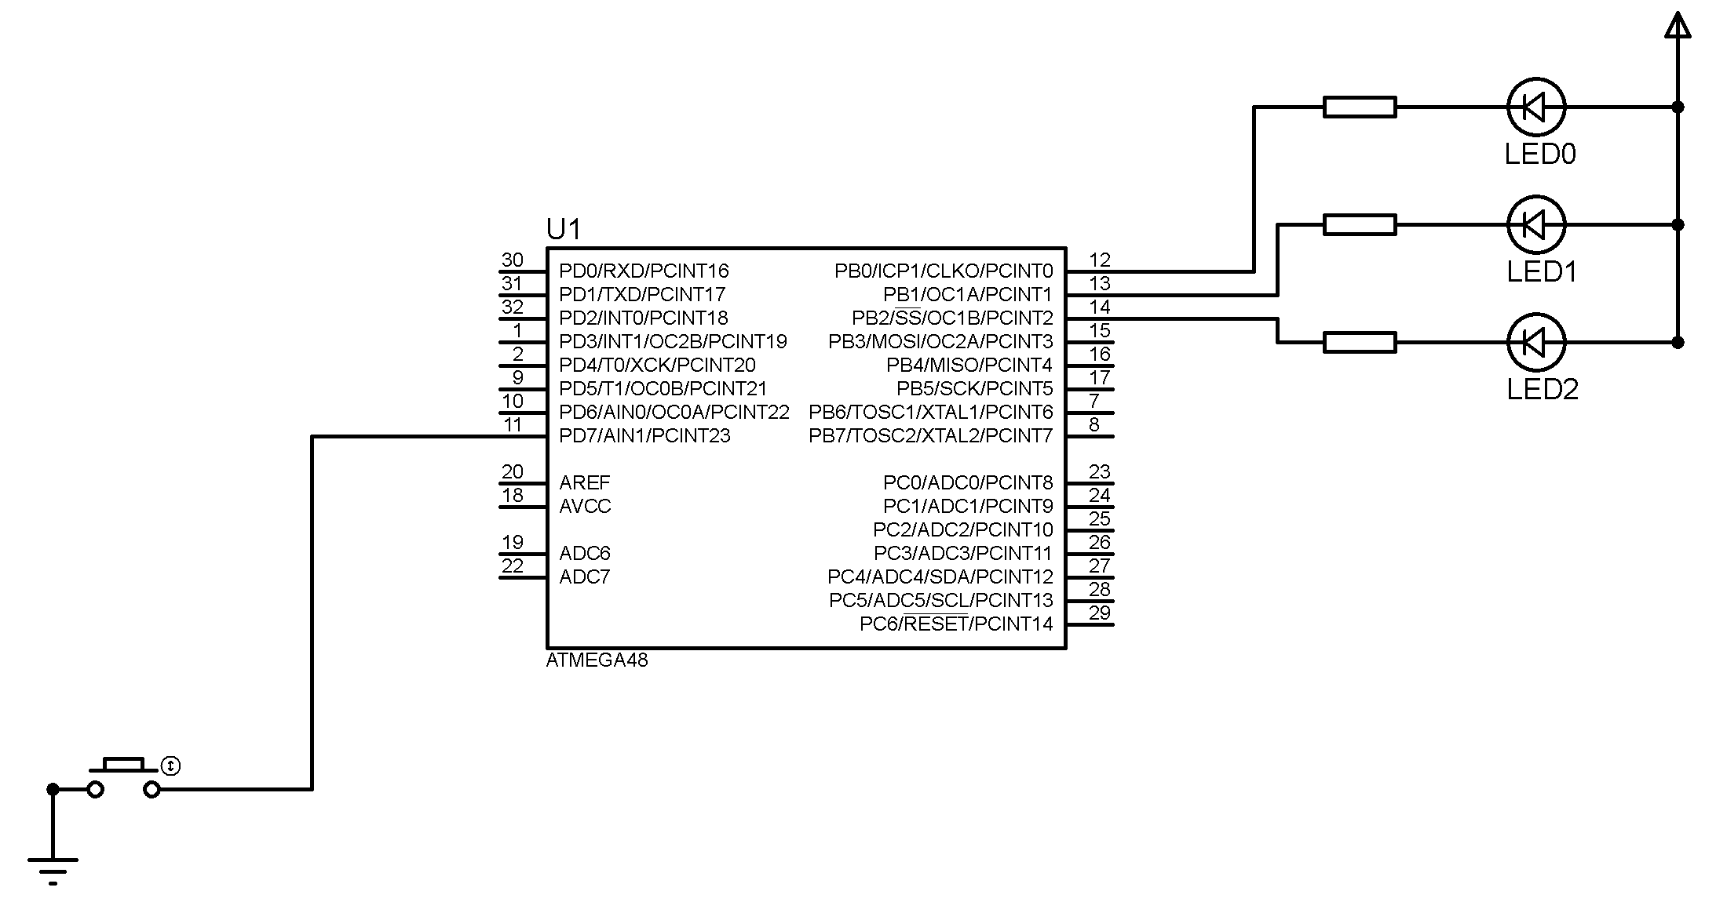

**Figure 1. ATMEGA48 I/O diagram**

Ⅳ Algorithm

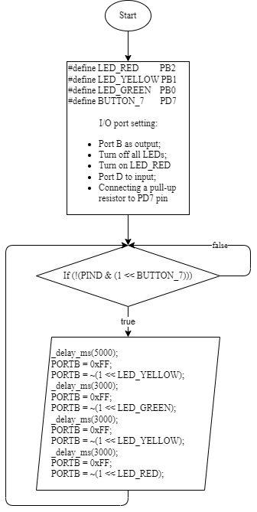

**Figure 2. ATMEGA48 algorithm**

Ⅴ Program code

#define *F_CPU* 8000000UL //definition of the clock frequency of the microcontroller

#include <avr/io.h> // Including I/O library

#include <util/delay.h> //Including a library with delay functions

#define LED_PORT PORTB

#define LED_RED PB2

#define LED_YELLOW PB1

#define LED_GREEN PB0

#define BUTTON_7 PD7

void turn_on_led(*uint8_t* index)

{

LED_PORT &= ~(1 << index); // Turn on LED at the specified index

}

*uint16_t* button_n_pressed(*uint8_t* index)

{

return !(PIND & (1 << index)); // Specific button pressed

}

void traffic_light_init(void)

{

DDRB |= (1 << LED_RED) | (1 << LED_YELLOW) | (1 << LED_GREEN); // Set LED pins as outputs

LED_PORT = 0xFF; // Initialize PORTB to 0xFF to turn off all LEDs initially

turn_on_led(LED_RED); // Turn on red LED

DDRD &= ~(1 << BUTTON_7); // Set button pin as input

PORTD = 1 << 7; // Connecting a pull-up resistor to PD7 pin

}

void traffic_light_cycle(void)

{

LED_PORT = 0xFF; // Turn off red LED

turn_on_led(LED_YELLOW); // Turn on yellow LED

*_delay_ms*(3000);

LED_PORT = 0xFF; // Turn off yellow LED

turn_on_led(LED_GREEN); // Turn on green LED

*_delay_ms*(3000);

LED_PORT = 0xFF; // Turn off green LED

turn_on_led(LED_YELLOW); // Turn on yellow LED

*_delay_ms*(3000);

LED_PORT = 0xFF; // Turn off yellow LED

turn_on_led(LED_RED); // Turn on red LED

}

int main(void)

{

traffic_light_init();

while (1) {

if (button_n_pressed(BUTTON_7)) { // Button pressed

*_delay_ms*(5000);

traffic_light_cycle(); // Switch colors

}

}

return 0;

}

Ⅵ Conclusion

In this laboratory work, the task was to develop a program for the ATMEGA48 microcontroller to control a traffic light consisting of three LEDs: red, yellow, and green. The program is designed to light the red LED constantly and switch the LEDs to yellow-green-yellow-red after a pedestrian presses the button SW7. Each color is lit for 3 seconds.

To implement this task, the I/O diagram of the microcontroller was created, and the main function algorithm was developed. The program code was written in Atmel Studio 7 (currently known as Microchip Studio) environment and tested by debugging. Time intervals were formed using functions that create delays. The clock frequency of the ATMEGA48 microcontroller is 8 MHz.

The program code was developed and tested in accordance with the individual task requirements. The features of the program include the use of inverse LED logic, where setting the LED pin to 0 turns the LED on and setting it to 1 turns it off. The program also includes the use of a pull-up resistor on the button pin.

During testing, the program worked as expected, constantly lighting the red LED and switching to the yellow-green-yellow-red sequence after the button was pressed. The report on this laboratory work was prepared, containing all the necessary information about the program and its implementation.